##### Look at the pictures. Which one is WRONG?

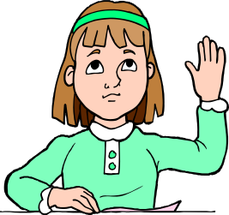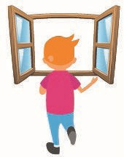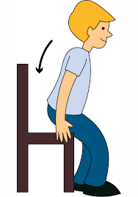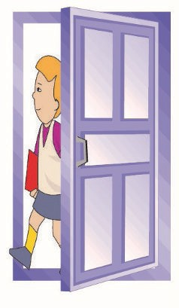

* 1. Raise your hand! B) Come in! C) Stand up! D) Close the window!

##### Look at the numbers.

10 20 30 40 ?

**Choose the correct answer.**

* 1. fifty B) forty-two C) forty D) thirty-five

##### Look at the board.

**15 + 20 = ?**

##### Choose the correct answer.

* 1. fifty-two B) forty-five C) fifty-five D) thirty-five

**ÖLÇME, DEĞERLENDİRME VE SINAV HİZMETLERİ GENEL MÜDÜRLÜĞÜ**

##### 1

1. **Which one is WRONG?**

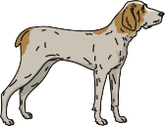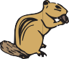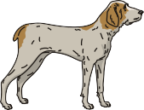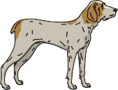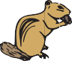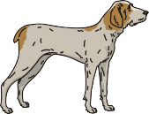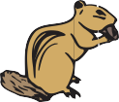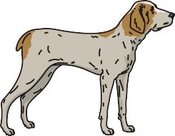

* 1. 14 + 16 = thirty B) 20 + 36 = seventy-six

C) 45 – 13 = thirty-two D) 56 – 15 = forty-one

##### Look at the chart.

|  |  |
| --- | --- |
| forty-one | thirty-two |
| thirty-three | fifty |

**Choose the correct answer.**

A) > > >

B) > > >

C) > > >

D) > > >

##### Read the dialogue.

**Joe** : Give me the eraser, please.

**Kate** : Sorry, - - - -.

##### Choose the correct answer.

* 1. sure B) of course

C) not right now D) here you are

**ÖLÇME, DEĞERLENDİRME VE SINAV HİZMETLERİ GENEL MÜDÜRLÜĞÜ**

##### 2

1. **Read the dialogue.**

**Marry** : May I - - - - your book, please?

**Jack** : Here you are.

**Marry** : Thank you.

##### Choose the correct answer.

* 1. give
  2. come
  3. take

D) listen

##### Read the dialogue.

**Karen :** Give me the sharpener, please.

**Kevin :** - - - -.

**Karen :** Thank you.

##### Choose the correct answer.

* 1. Sure, here you are B) Say that again, please

C) Raise your hand D) Stay in the line

##### Read the speech bubbles.

May I open the window?

May I come in?

##### Mary

**Jane**

May I go to toilet?

May I clean the board?

##### Jack

**Mark**

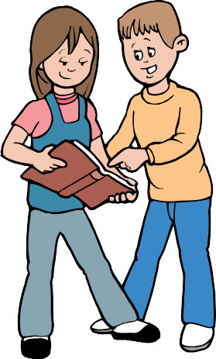

Who is late for school?

##### Choose the correct answer.

* 1. Mary B) Jane C) Jack D) Mark

**ÖLÇME, DEĞERLENDİRME VE SINAV HİZMETLERİ GENEL MÜDÜRLÜĞÜ**

##### 3

1. **Put the sentences in order.**

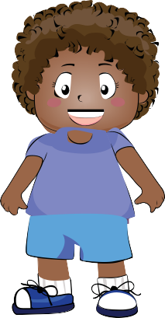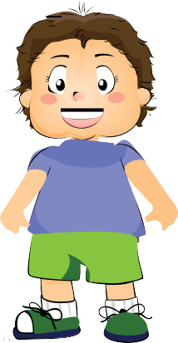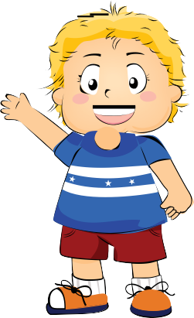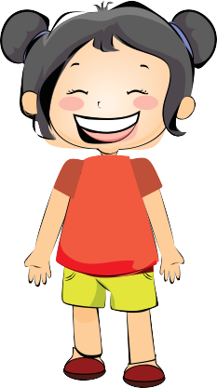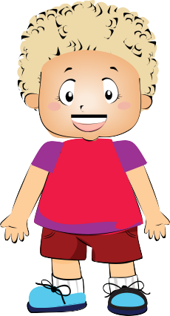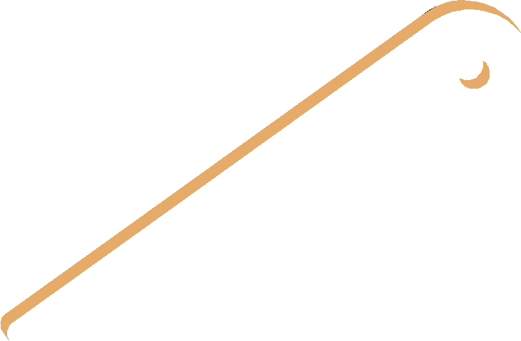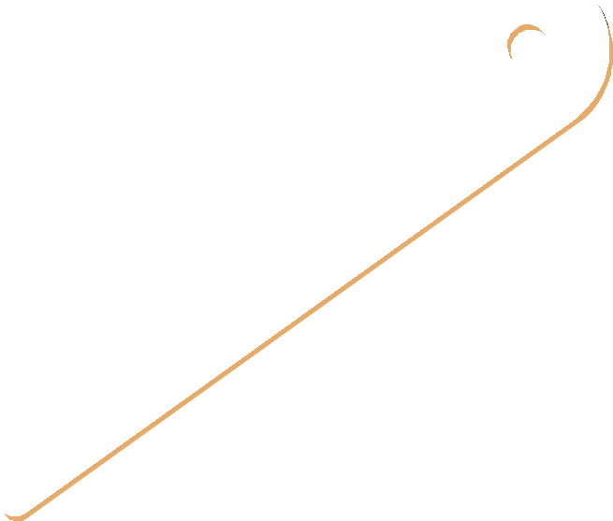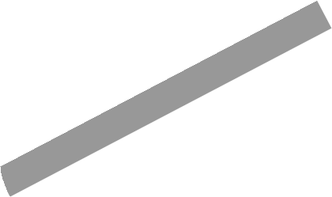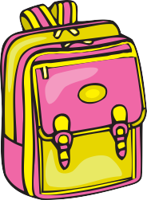

1. Say that again, please.
2. Ruler, please.
3. May I take your ruler?
4. Here you are.
5. Thank you.

##### Choose the correct answer.

A) I-III-II-IV-V B) III-V-I-IV-II

C) II-IV-I-III-V D) III-I-II-IV-V

##### Look at the picture. Match the classroom objects and students.

Mike Sue Sam Linda Joe

**Choose the correct answer.**

A)

|  |  |  |  |  |
| --- | --- | --- | --- | --- |
| **Mike** | **Sue** | **Sam** | **Linda** | **Joe** |
| sharpener | eraser | scissors | ruler | schoolbag |
| ruler | scissors | schoolbag | sharpener | eraser |
| eraser | sharpener | ruler | schoolbag | scissors |
| eraser | sharpener | scissors | ruler | schoolbag |

B)

C)

D)

**ÖLÇME, DEĞERLENDİRME VE SINAV HİZMETLERİ GENEL MÜDÜRLÜĞÜ**

##### 4

1. **Read the dialogue.**

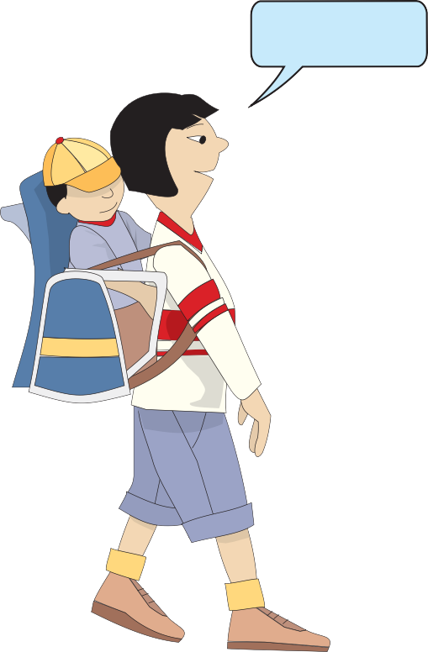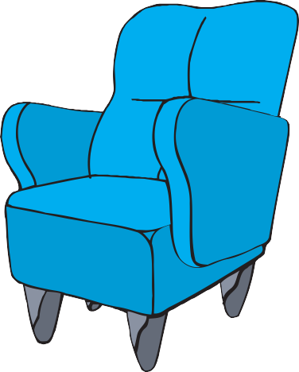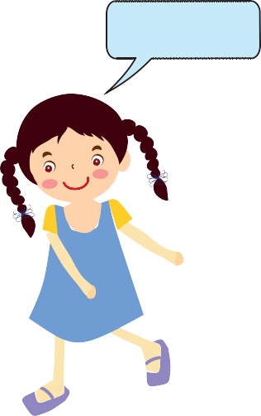

Thank you!

- - - - .

##### Choose the correct answer.

* 1. Sit down, please B) Give me the baby, please

C) Sorry, not right now D) Stay in the line

##### Read the speech bubble.

How many pencils are there?

##### Choose the correct answer.

* 1. twelve B) nineteen

C) sixteen D) thirteen

**ÖLÇME, DEĞERLENDİRME VE SINAV HİZMETLERİ GENEL MÜDÜRLÜĞÜ**

##### 5

1. **Put the words in order.**

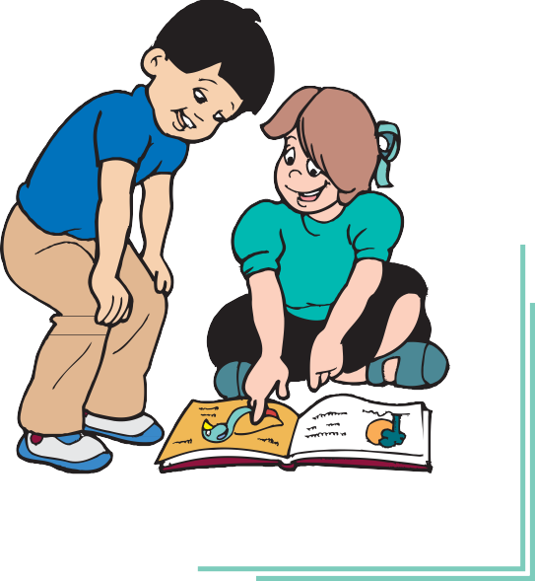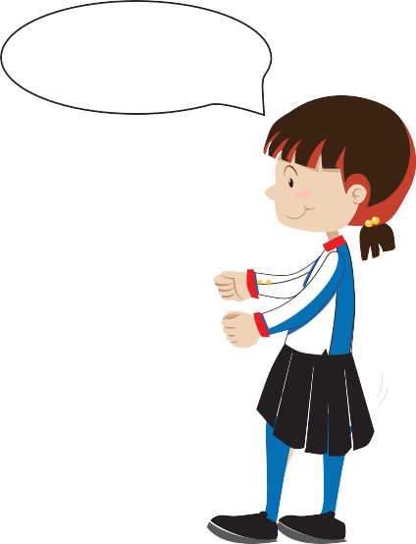

**CLEAN**

**THE**

**MAY**

### BOARD

**I PLEASE**

##### Choose the correct answer.

* 1. May I board the clean, please?
  2. May I clean the board, please?
  3. Please, may I board the clean?

D) The board may I clean, please?

##### Look at the picture.

- - - - !

##### Choose the correct answer.

* 1. Close your notebook B) Stand up

C) Stay in the line D) Close the window

##### Read the dialogue.

**Steve**: Give me the book, please.

**Janet**: - - - -

**Steve**: The book, please.

**Janet**: Sorry, not now.

##### Choose the correct answer.

* 1. Here you are.
  2. You are welcome.
  3. May I take your book?

D) Say that again, please.

**ÖLÇME, DEĞERLENDİRME VE SINAV HİZMETLERİ GENEL MÜDÜRLÜĞÜ**

##### 6

1. **Look at the picture.**

**Choose the correct answer.**

* 1. Give her the notebook, please.
  2. Turn on the light, please.
  3. May I come in?

D) Clean the board, please.

- - - -

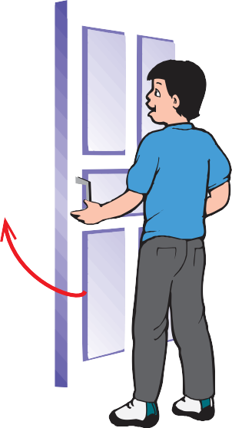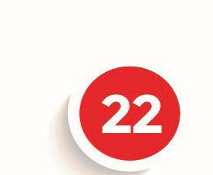

##### Look at the picture. Choose the correct answer.

* 1. Twenty-one
  2. Twenty-two
  3. Thirty-two

D) Forty-two

##### Look at the picture. Choose the correct answer.

* 1. Close the door.
  2. Open the door.
  3. Here you are.

D) Open the window.

**ÖLÇME, DEĞERLENDİRME VE SINAV HİZMETLERİ GENEL MÜDÜRLÜĞÜ**

##### 7

1. **Read the speech bubble.**

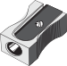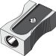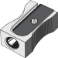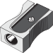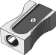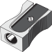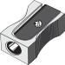

I am Tarık. I am a 4th grade student. I love my school. I like

books, notebooks, colourful pencils, erasers, and sharpeners. In my pencil case, I have three pencils, two pencil sharpeners, a pen, and five erasers. I haven’t got a ruler.

What does Tarık have in his pencil case?

##### Choose the correct answer.

A)

B)

C)

D)

**ÖLÇME, DEĞERLENDİRME VE SINAV HİZMETLERİ GENEL MÜDÜRLÜĞÜ**

##### 8

1. **Look at the picture.**

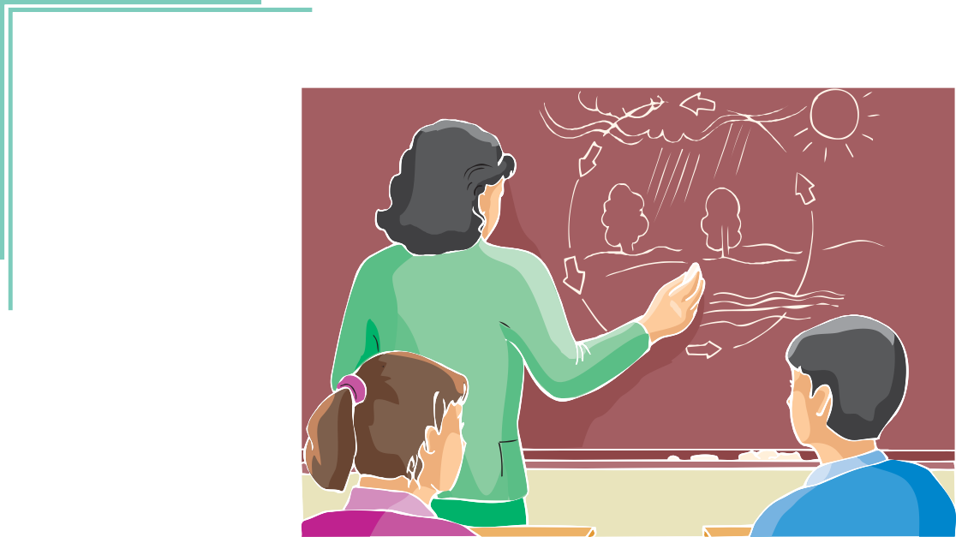

The classroom is dark and Clara cannot see the board. She asks - - - - ?

##### Choose the correct answer.

* 1. May I come in B) Can you clean the board

C) Can you close the door D) May I turn on the lights

##### Look at the pictures.

43 24 33 34

Sevil knocks on the door number thirty-three.

##### Choose the correct answer.

A) 43 B) 24 C) 33 D) 34

**ÖLÇME, DEĞERLENDİRME VE SINAV HİZMETLERİ GENEL MÜDÜRLÜĞÜ**

##### 9

1. **Read the speech bubbles.**

Yes, - - - - .

# May I come in?

y I com in?

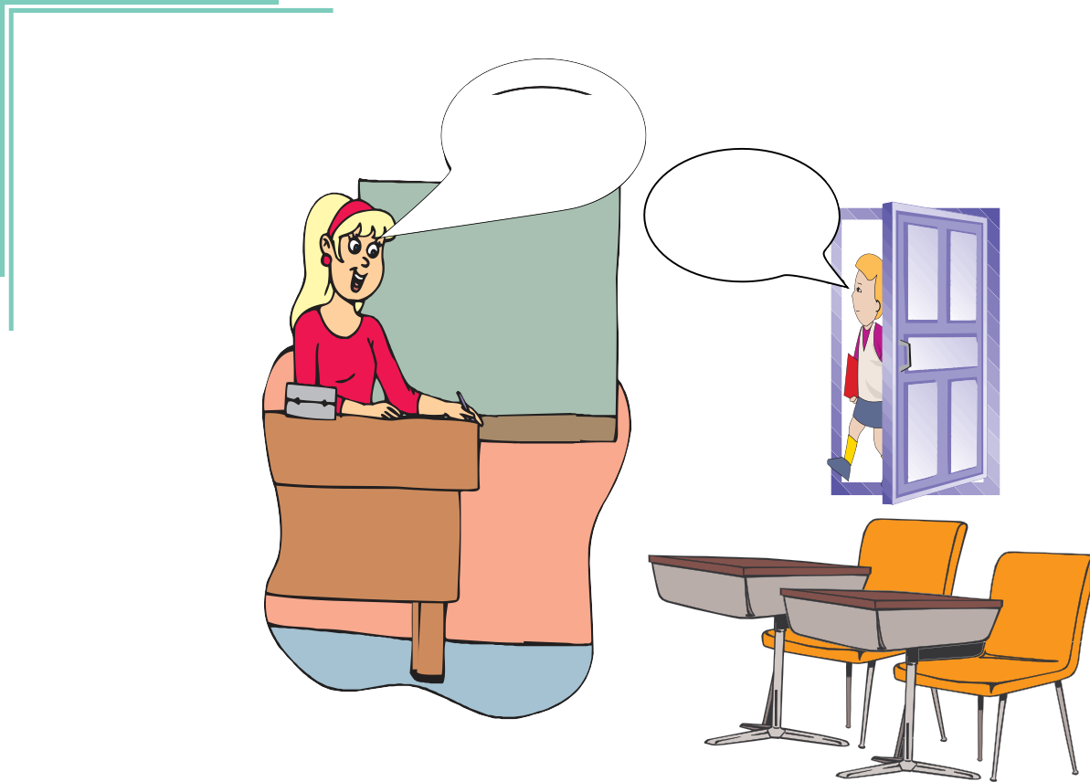

##### Choose the correct answer.

* 1. I am sorry B) of course

C) not right now D) stand up please

##### Look at the picture. Count the apples.

**Choose the correct answer.**

* 1. There are nine apples. B) There are eighteen apples.

C) There are eight apples. D) There are six apples.

**ÖLÇME, DEĞERLENDİRME VE SINAV HİZMETLERİ GENEL MÜDÜRLÜĞÜ**

##### 10

**25. 40 + 7 =**

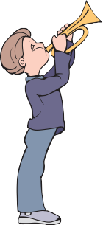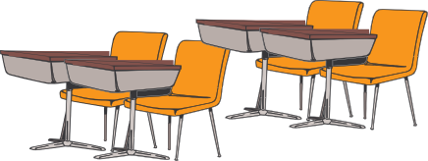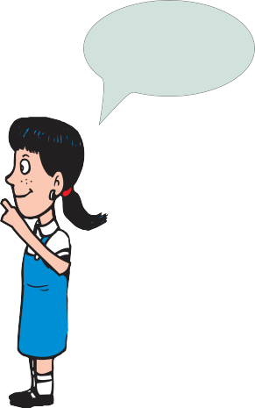

##### Choose the correct answer.

A) twenty-seven B) forty-seven C) thirty-seven D) seventy-seven

##### Look at the numbers.

|  |  |  |  |  |  |  |  |  |
| --- | --- | --- | --- | --- | --- | --- | --- | --- |
| **8** | **12** | **16** | **20** | **?** | **28** | **32** | **36** | **40** |

**Choose the correct answer.**

* 1. twelve B) twenty-one C) twenty-four D) twenty-seven

##### Look at the picture.

- - - -.

##### Choose the correct answer.

* 1. Clean the board, please B) Open the window, please

C) Come in, please D) Be quiet, please

**ÖLÇME, DEĞERLENDİRME VE SINAV HİZMETLERİ GENEL MÜDÜRLÜĞÜ**

##### 11

1. **Look at the picture.**

May I come n ?

- - - - .

##### Choose the correct answer.

* 1. Sure B) Leave it here, please

C) Thank you D) You’re welcome

##### Look at the picture.

**Choose the correct answer.**

* 1. Raise your hand!
  2. May I come in?
  3. Please, give me your ruler.

D) Give me your book, please.

- - - - Here you are

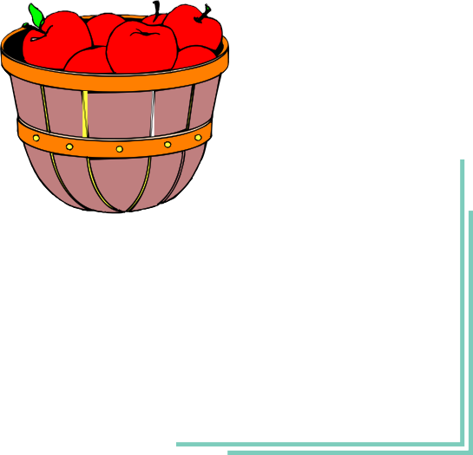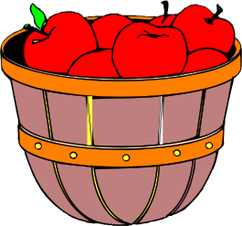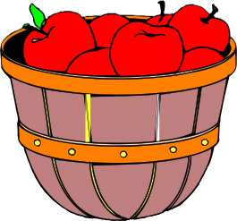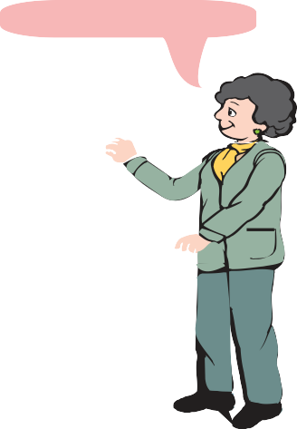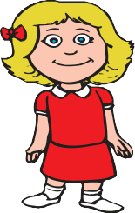

##### Look at the picture.

I have three baskets. There are seven apples in a basket.

##### How many apples are there in three baskets?

**Choose the correct answer.**

A) nineteen B) twenty C) twenty-one D) twenty-two

**ÖLÇME, DEĞERLENDİRME VE SINAV HİZMETLERİ GENEL MÜDÜRLÜĞÜ**

##### 12

1. **Look at the picture.**

May I take your pencil?

- - - -.

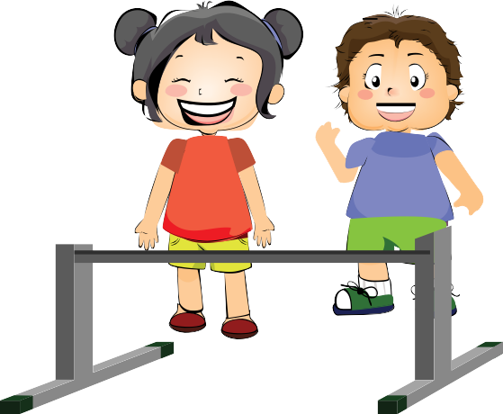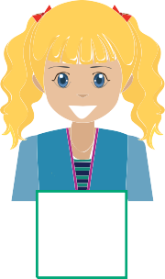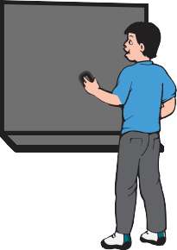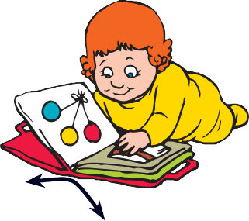

##### Choose the correct answer.

* 1. Here you are B) Clean the board

C) Come in D) Sit down

##### Look at the picture.

**10 ---- 30 40**

##### Choose the correct answer.

* 1. eleven B) twelve C) twenty D) fifty

##### Look at the pictures.

*3+4=4*

*3+4=4*

##### Choose the ODD one out.

* 1. Clean the board. B) Turn around.

C) Open the book. D) Be quiet.

**ÖLÇME, DEĞERLENDİRME VE SINAV HİZMETLERİ GENEL MÜDÜRLÜĞÜ**

##### 13

**ÖLÇME, DEĞERLENDİRME VE SINAV HİZMETLERİ GENEL MÜDÜRLÜĞÜ**

##### 14